|  |  |
| --- | --- |
| http://sphotos.ak.fbcdn.net/photos-ak-snc1/v2219/119/28/51288393663/n51288393663_1327303_6197.jpg | old_logo_color |

ASSIGNMENT Week 1

Improving Deep Neural Networks Hyperparameters

By

Ahmed Usama Khalifa

Submitted to

Dr. Omar Nasr

Electronics and Electrical Communications Engineering Department

FACULTY OF ENGINEERING, CAIRO UNIVERSITY

GIZA, EGYPT

Regularization   
The **regularization parameter** is a control on your fitting parameters. As the magnitudes of the fitting parameters increase, there will be an increasing penalty on the cost function. This penalty is dependent on the squares of the parameters as well as the magnitude of.

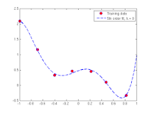

Dropout

The term “**dropout**” refers to **dropping out** units (both hidden and visible) in a neural network. Simply put, **dropout** refers to ignoring units (i.e. neurons) during the training phase of certain set of neurons which is chosen at random.

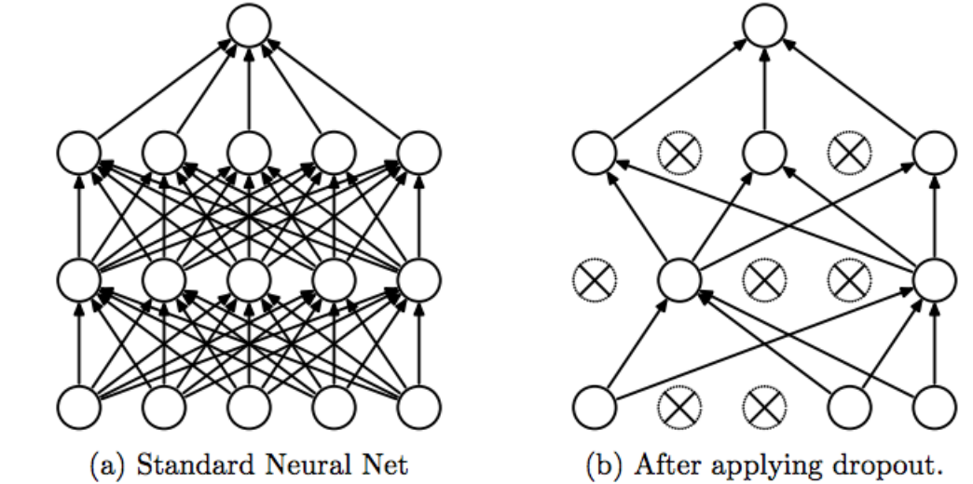

Normalize input

**Normalization** is a technique often applied as part of data preparation for **machine learning**. The goal of **normalization** is to change the values of numeric columns in the dataset to a common scale, without distorting differences in the ranges of values. For **machine learning**, every dataset does not require **normalization**.

Weight initialization for Deep Networks

The aim of **weight initialization** is to prevent layer activation outputs from exploding or vanishing during the course of a forward pass through a **deep neural network**.  
